Oakland County Children’s Village
DONATIONS SPECIFIC FOR MANDY’S PLACE

Mandy’s Place Shelter Care is short-term housing for children ages 0-17 who have been removed from their homes by the court due to neglect, abuse and status offenses. The residents are waiting to return to their family, go to foster care, be placed in Children’s Village residential programing or to another agency. Our goal is to provide care, safety and security to the best of our ability until the Court or Department of Health and Human Services (DHHS) has made a decision.

To reinforce positive behavior Mandy’s Place Shelter Care has a “store” in which the residents can purchase items with earned tokens.

The store works in conjunction with a daily point system. The point system is based off of a token economy which reinforces positive behavior. The purpose of the point system is to track behaviors in the program and reward children for displaying positive behaviors. Residents are awarded tokens everyday for their behavior. At the end of the week the residents are allowed to use those tokens to purchase items at the store. The store contains everything from snacks, toys and personal hygiene items.

The top requested donations for “The Store” include:
- Action figures (Spiderman, wrestlers, Barbie dolls)
- Non-aerosol body sprays/lotions for males and females
- Shampoo and conditioner (regular and travel size)
- Hand held electronic games (Solitaire, Uno, Tetris)
- Hair weaving in a variety of colors
- Puzzles 100-200 piece and 200-500 piece
- Sudoku puzzle books and adult coloring books

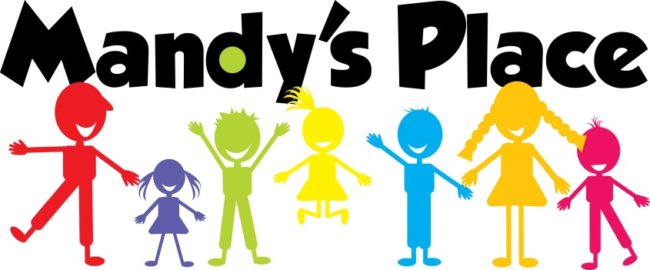
For more information on the Mandy’s Place Store or how to donate items please contact
(248)858-1811 or (248)858-4099

Oakland County Children’s Village
248.858.1150
1200 N Telegraph Rd | Pontiac, MI 48341-0444
www.oakgov.com/villagee

